# Lab: Web API

Lab for the ["ASP.NET Advanced" course @ SoftUni](https://softuni.bg/trainings/4369/asp-net-advanced-february-2024)

In this task, we will create a **simple REST API** for **displaying**, **creating**, **editing** and **deleting products**. We will try out the **API functionalities** with the help of the Postman **tool**. At the end, we will use the Swagger **tool** to **document** **our API** and **try it out** directly from the browser.

## Web API for Products

### Step 1: Create and Clean the Project

Let's start with **creating the API**. Open Visual Studio and choose the "ASP.NET Core Web API" **template**:

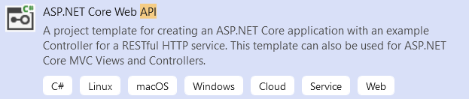

**Create the API** with the current .NET **version**. It does **not need authentication**! When created, the **solution** should look like this:

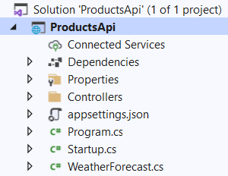

As you can see, we have an **API controller** for **weather forecast**. We won't need it, so **delete** the WeatherForecastController and WeatherForecast **classes**:

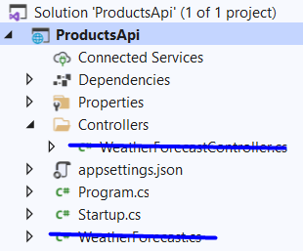

Now you can **run the app**. You will see that we have Swagger as a **part of our API** (coming from the **template**), but it does not show anything, as we **do not have any controllers** and actions yet:

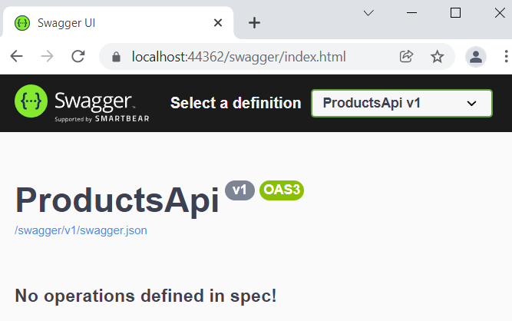

### Step 2: Create a Database

We will need to **create a database** for our **products**. However, you can see that we **do not have a** dbcontext and we should **create it** from scratch.

To begin with, **download** the Entity Framework Core NuGet **packages** we will need for creating the database:

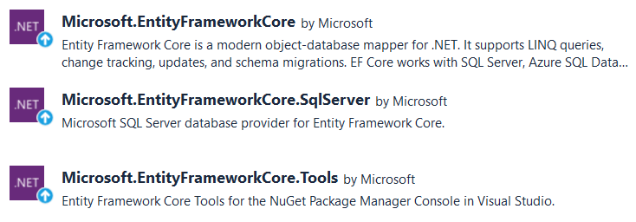

Then, create a **folder** "Data", which will hold the data-related classes. In it, **create the** Product **class**, which should have **properties for id**, **name** and **description**:

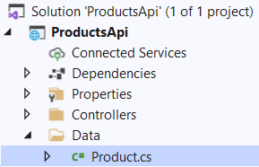 🡪 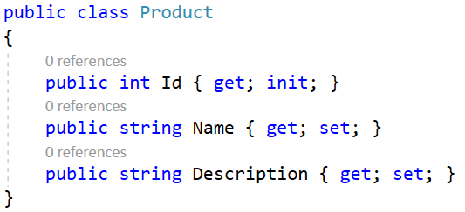

Then, create the ProductDbContext **class** in the "Data" **folder**. It should have a DbSet for **products** and should **invoke the** EnsureCreated() **method in the constructor**. In this way, we will **create the database** but we won't be able to change it, unless we **apply new migrations** to the database **manually**:

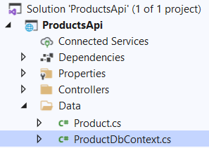 🡪 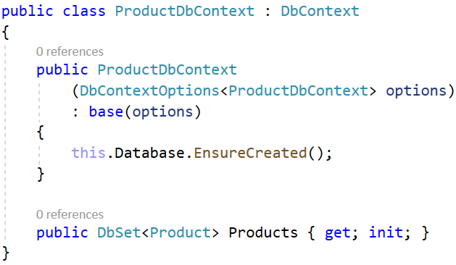

Next, we should **add a connection string** to the appsettings.json **file**, so that we can **connect to** SQLServer. Add the following lines like this:

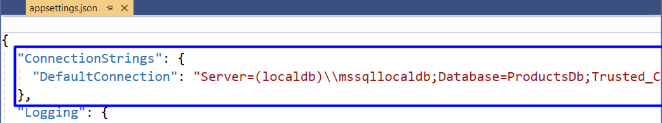

You can **copy the connection string** from here:

|  |
| --- |
| Server=(localdb)\\mssqllocaldb;Database=ProductsDb;Trusted_Connection=True;MultipleActiveResultSets=true |

Next, we should **register the** dbcontext **class** as a **service**. Do this in the Program **class**, you should already know how to do that.

At the end, we should just **add a migration**, which will be applied, so that our **database is created**. To do this, **open** the Package Manager Console from [Tools] 🡪 [NuGet Package Manager] and **add the migration** like this:

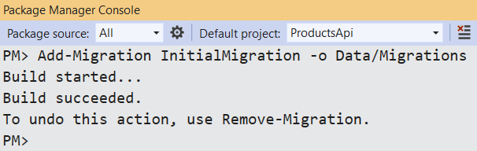

The **migration** should appear in the "/Data/Migrations" **folder**:

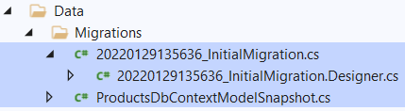

**Run your app** again. Open SQL Server Management Studio and you should see the **newly-created database**. It has a single **table** "Products":

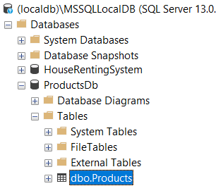 🡪 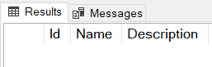

Now you can start building your **API controller**.

### Step 3: Create the API Controller Class

To **create an API controller**, you should first **create a standard controller class** and **add the needed attributes**. Create the ProductsController **class** in the "Controllers" **folder**:

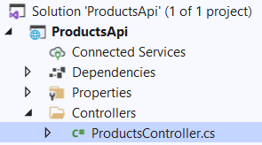 🡪 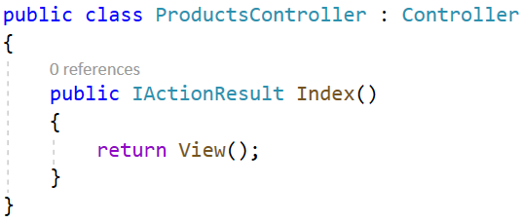

**Remove** **the** Index() **method**, as we won't need it. Then, add the [ApiController] and [Route] **attributes** to make the controller and **API controller**:

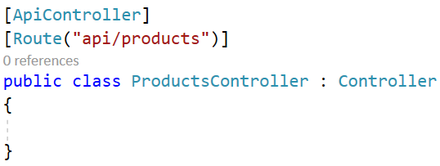

Note that our controller methods will be **accessed** on "/api/products" because this is how we set it in the [Route] **attribute**.

We want our **business logic** to be implemented in **service methods** and the **controller to use them directly**. For this reason, we should create a new **folder** "Services" with an IProductService **interface** and an ProductService **class**. The class should accept the db context from the **constructor**:

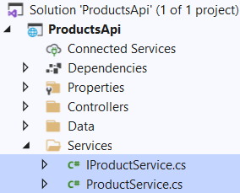 🡪 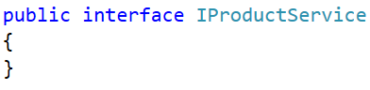 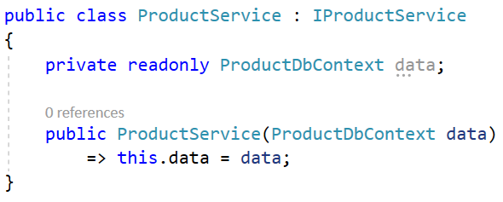

Don't forget to **register the service** in the Program **class**.

Now go back to the ProductsController **class** and **inject the created service**:

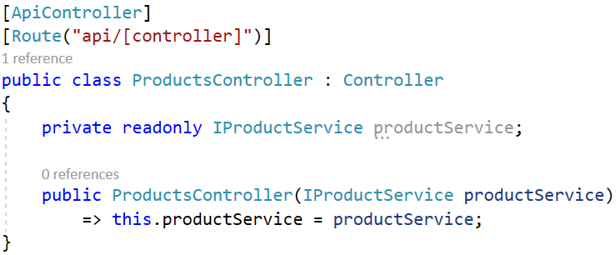

### Step 4: Write the API Controller Methods

#### GetProducts() Method

The first method should **return all products** as an ActionResult with a **collection of type** Product (we won't create and return a model, as we have a pretty basic class for the product). The **controller method** should use a **service method** and should be i**nvoked on a "**GET**" request to "**/api/products**"**. Do it like this:

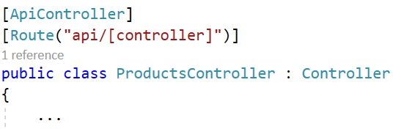 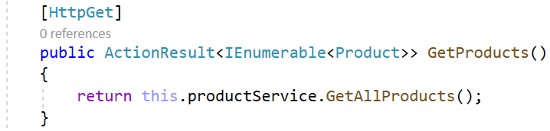

The IProductService and ProductService **classes** define and implement the GetAllProducts() **method**:

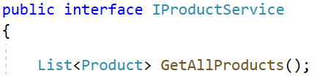

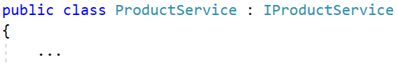 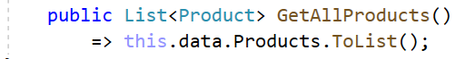

**Run** the app. Then, open Postman and **create a "**GET**" request to "**/api/products**"** (use the **whole URL**):

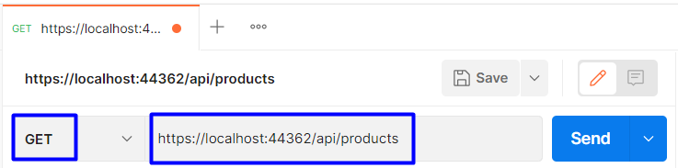

The **returned response** should be with **status code** "200 OK" but will return an **empty JSON object**, as we don't have **any products in our database** yet:

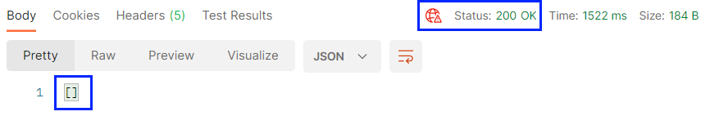

You can **open** SQL Server Management Studio and **add some products** to display:

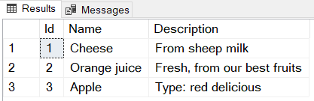

Then, if you **send the request** in Postman again, you should see the above **products returned as JSON**:

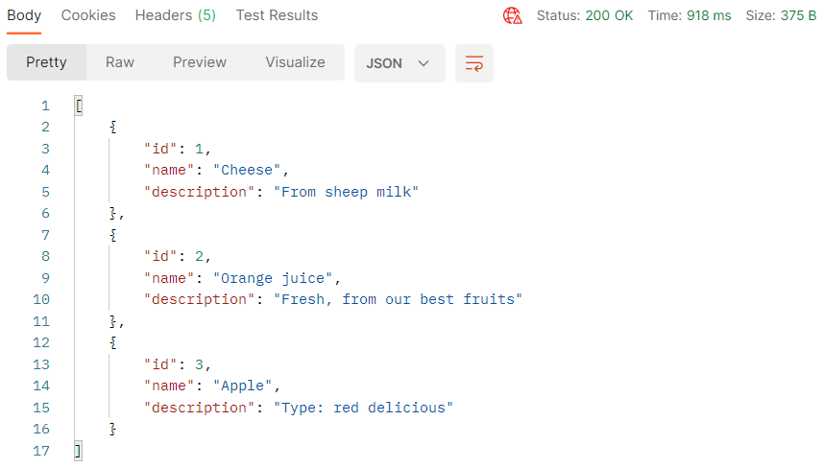

#### GetProduct() Method

The GetProduct(int id) method should **return a product by a given id** if it exists. If it **doesn't exist**, a "404 Not Found" **response** should be returned. The method should be **invoked on a "**GET**" request to "**/api/products/{id}**"**. Write it in the ProductsController **class** like this:

 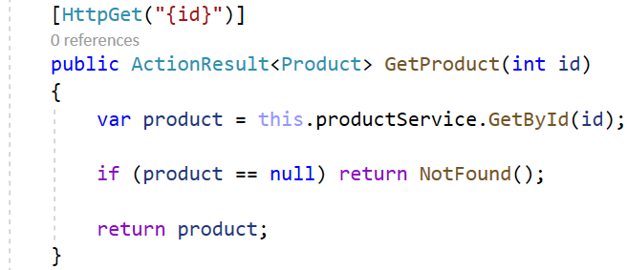

The GetById() **service method** should look like this:

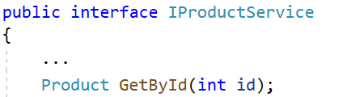

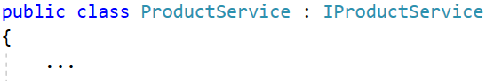 

Now **try out the method** in Postman by sending a "GET" **request** to "/api/products/{id}". If you **send an id** of an **existing product**, the **product should be returned**:

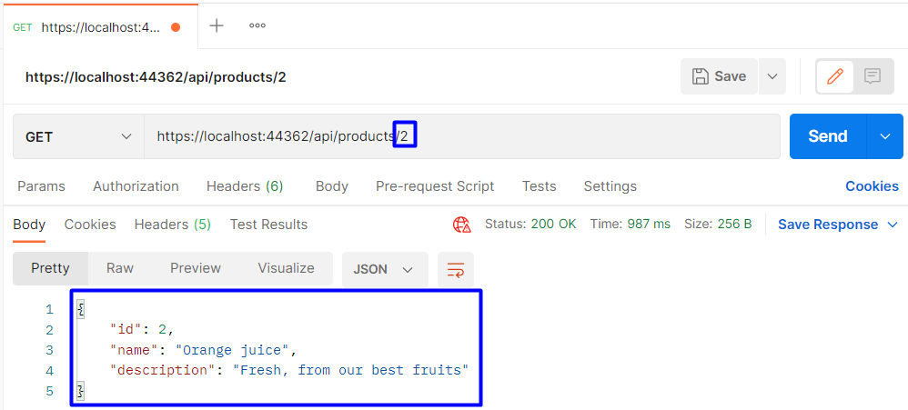

If you **send an invalid id**, a "404 Not Found" **response** should be **returned** (again as **JSON**):

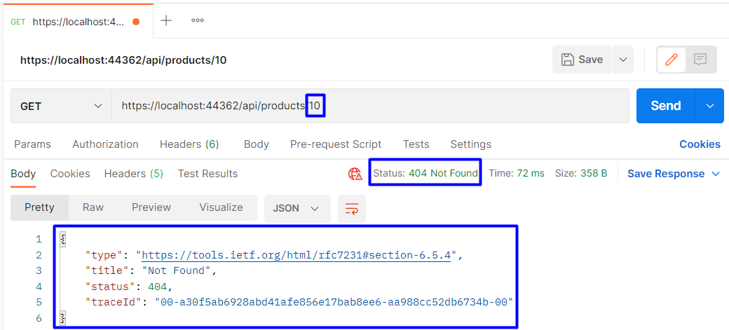

#### PostProduct() Method

The PostProduct(Product product) **controller method** is responsible for **creating a new product** in the database. When the **product is created**, a "201 Created" **response** should be returned, which will invoke the GetProduct(int id) **method** to **return the product**. It should be invoked on a "POST" **request** to "/api/products":

 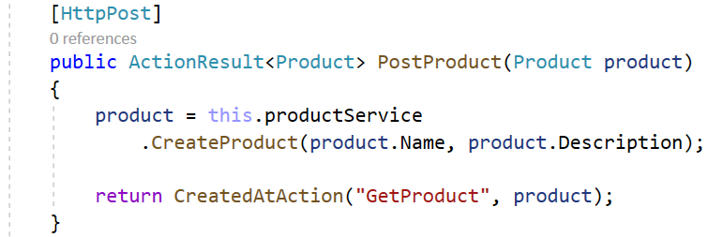

The CreateProduct() **service method** is the following:

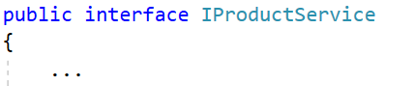 

 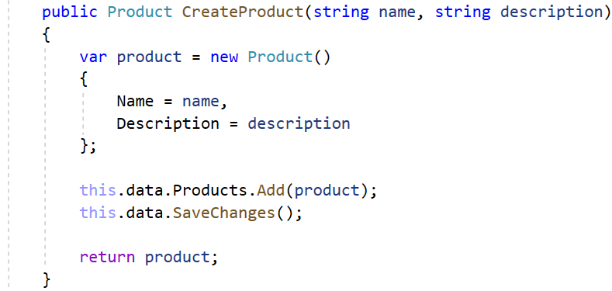

**Run the app** and **try to create a new product** in Postman. To do this, you should send a "POST" **request** to "/api/products" and **add a body to the request** with the **new product**. The **body** should be in a **raw JSON format**. Do it like this:

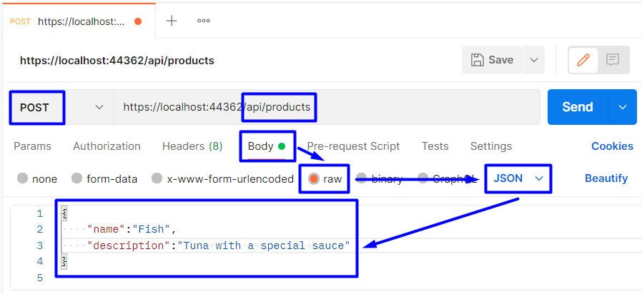

The **response** should be the following if the **product is created successfully**:

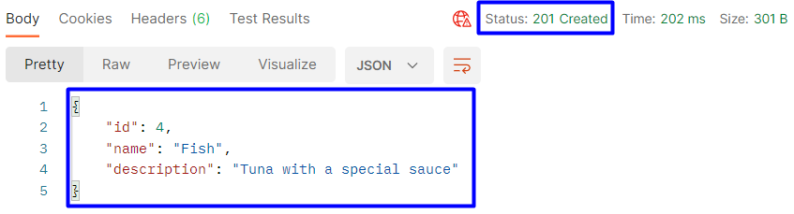

The **new product** should appear in the **database**:

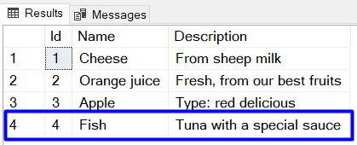

#### PutProduct() Method

The PutProduct(int id, Product product) **method** of the ProductsController should be invoked on a "PUT" **request** to "/api/products/{id}" with the **data of the product** (**modified** and **non-modified**). If the product id from the **URL** and from the **request body are not the same**, a "400 Bad Request" **response** is returned. If a **product with the** **given id does not exist**, a "404 Not Found" **response** is returned. If the product is **edited** **successfully**, a "204 No Content" **response** is returned.

Write the action like this:

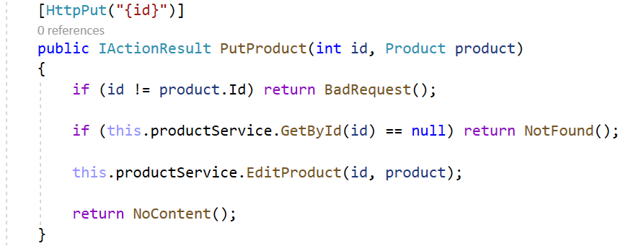

The EditProduct(…) **service method** is shown below:

 

 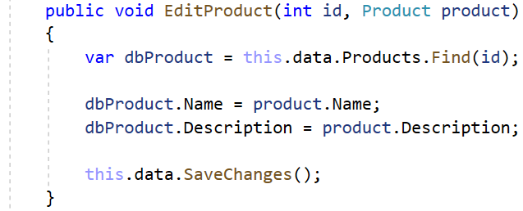

Try to **edit the product** we created in Postman. Send a "PUT" **request** to "/api/products/{id}" with an **existing** **product id** and with the **product data**. Note that you should include **all the product data** in the **request body**, no matter if it is modified or not. If you **miss a property**, a NULL **value** will be assigned to it.

Now **edit an existing product** in Postman like this:

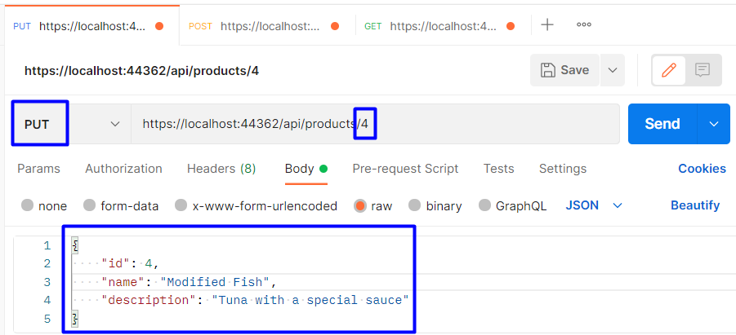

If the **edit is successful**, an **empty** "204 No Content" **response** should be returned:

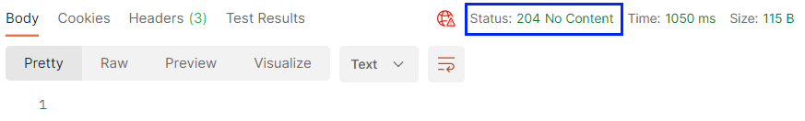

The **product** should be **modified in the database**, as well:

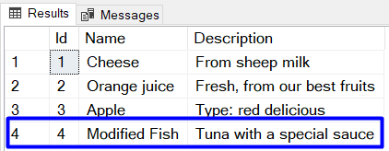

If you **send a request** in Postman with **different ids in the URL and in the body**, a "400 Bad Request" should be returned:

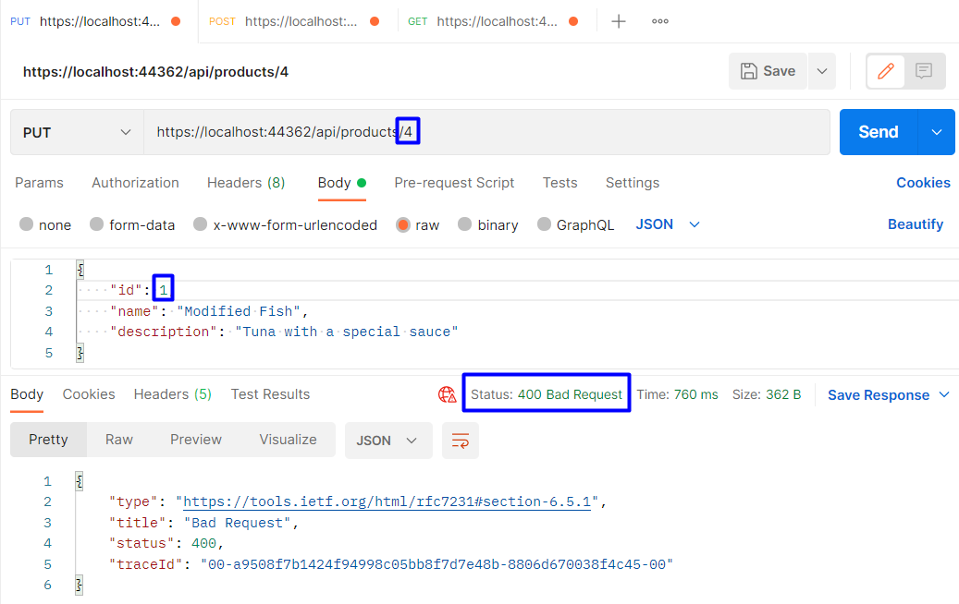

If you **send a product with an id**, which **does not exist** in the database, a "404 Not Found" **response** should be returned:

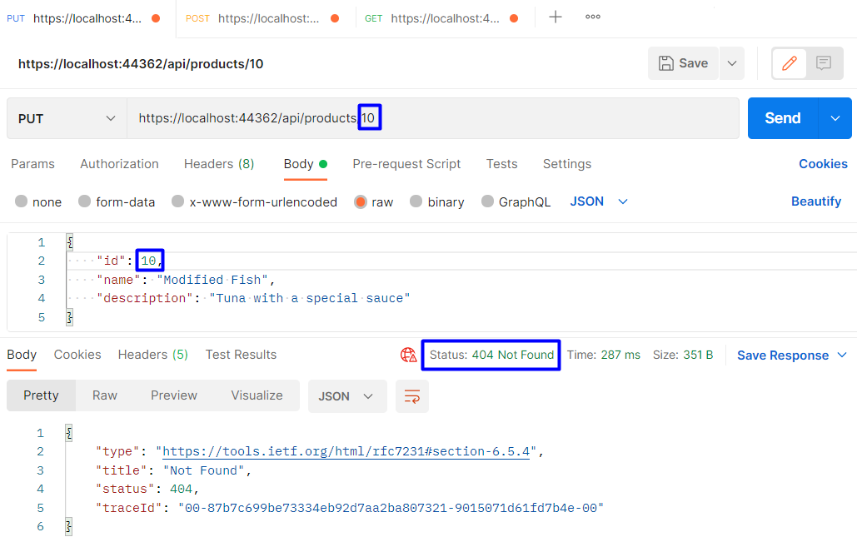

#### PatchProduct() Method

The PatchProduct() **method** is pretty **similar** to the PutProduct() one we created. The difference is that when you send a "PUT" **request**, the **request body should contain the whole product data**, while the "PATCH" **request** body should **only have the modified property values**.

The PatchProduct(int id, Product product) **method** of the ProductsController should be invoked on a "PATCH" **request** to "/api/products/{id}" with **partial** **data of the product** (**only** **modified**). If a **product with the** **given id does not exist**, a "404 Not Found" **response** is returned. If the product is **edited** **successfully**, a "204 No Content" **response** is returned.

Write the action like this:

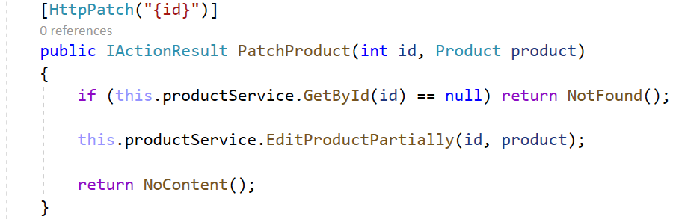

The EditProductPartially() **service method** should **check model properties for** null **values** and **modify some fields with the provided data**:



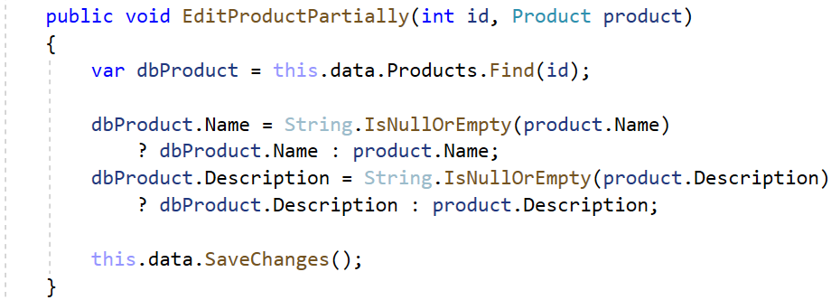

Now create a "PATCH" **request** in Postman to "/api/products/{id}" with a **valid id** and with **modified data** **only**:

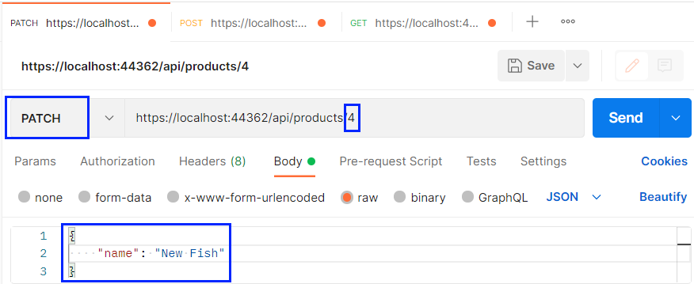

The **product title** should be **modified** successfully and a "204 No Content" **response** should be returned:



Check the **modification in the database**, as well:

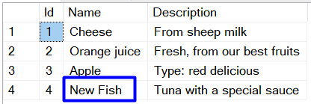

#### DeleteProduct() Method

The DeleteProduct(int id) **method** is the last method we will implement. It should be invoked on a "DELETE" **request** to "/api/products/{id}". If a **product with the given id doesn't exist**, "404 Not Found" is returned. If it **exists**, the **deleted product is returned**:

 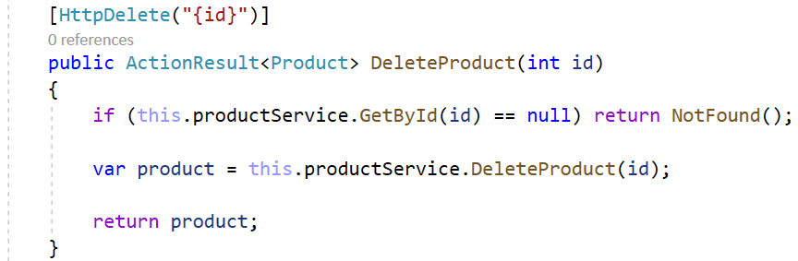

The DeleteProduct(…) **service method** is the following:

 

 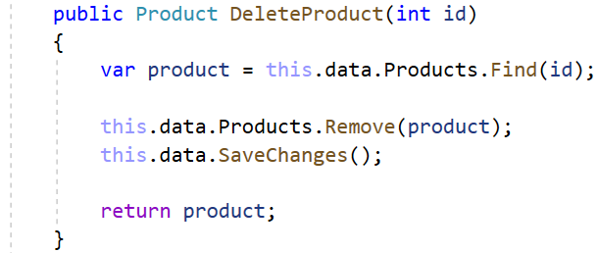

Try to **delete the product** we created in Postman. Create the following **request** and make sure that the **product is** **returned in the response**:

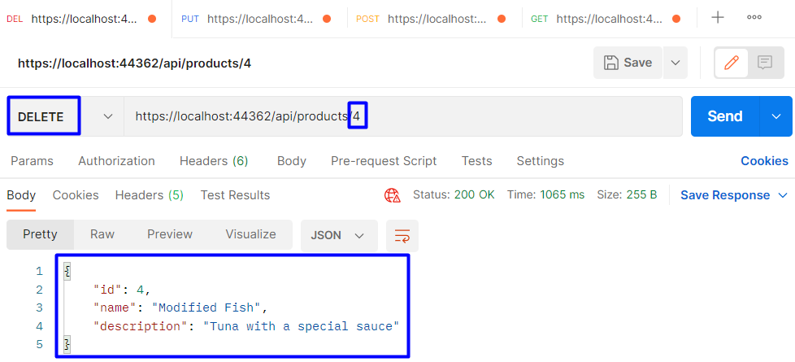

Now you have an **implemented REST API** with **ASP.NET Core**.

### Step 4: Write the API Swagger Documentation and Try It Out

Finally, we will see how to write OpenAPI **documentation** for Swagger, so that it **displays correct and full** **information** about our **API methods**.

To begin with, if you **run the app** we created, you will see that Swagger **already** **displays** **our** **API controller methods**:

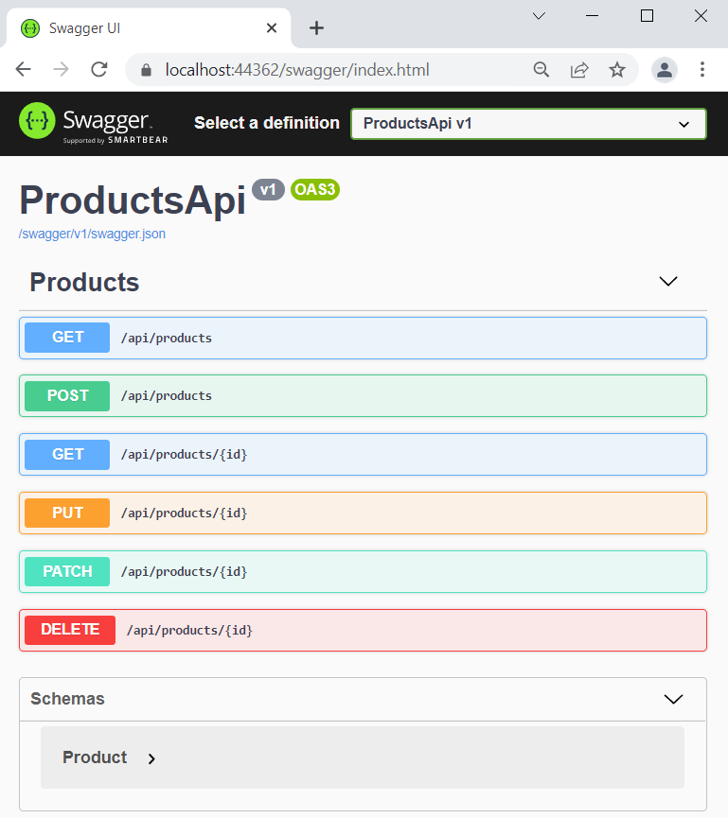

After we **add documentation**, the Swagger **page** will look like this:

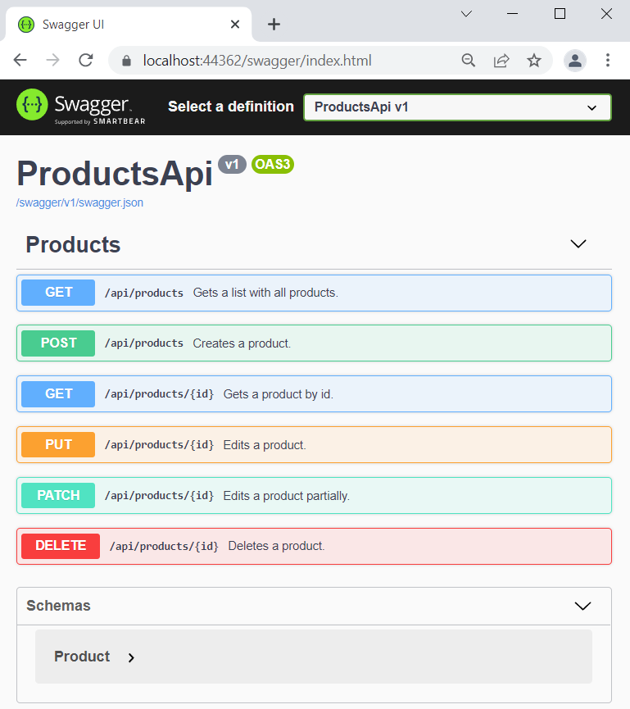

To do this, we should first **enable XML comments** (the ones you see on each method). These comments will be **saved in an XML file** as a part of your project. To **create such a file**, go to the ConfigureServices(…) **method** of your Startup **class** and **add the following lines** to the **default** Swagger **options**:

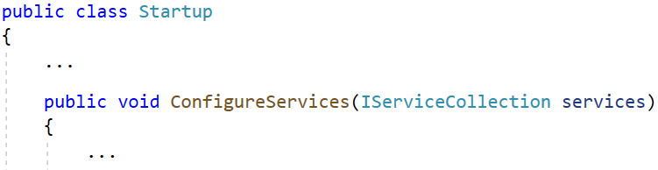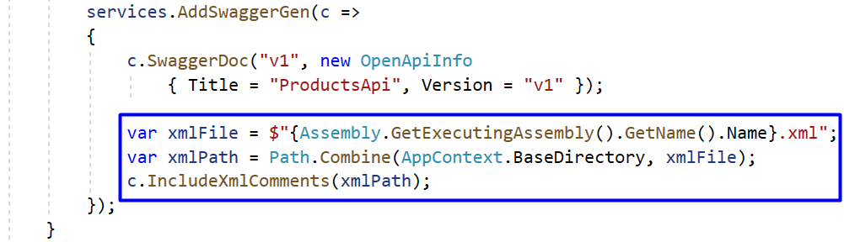



Next, we should **go to the** .csproj **file** of our project and **suppress warning messages**, which indicate undocumented types and members. Also, we want our **XML file to be created**, so **add the following lines**:

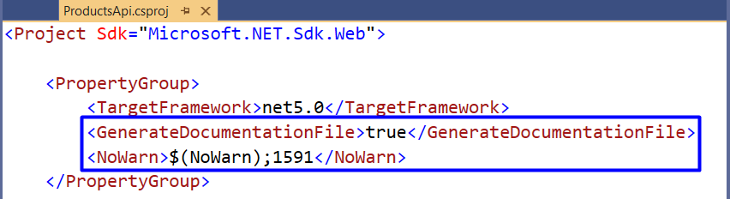

As we **have the file**, let's **add the documentation**, which it will contain. To do this, we will **add triple-slash comments** to ProductsController **actions** with a **summary** of what the action does, a **sample request** and the **responses**. Do it like this:

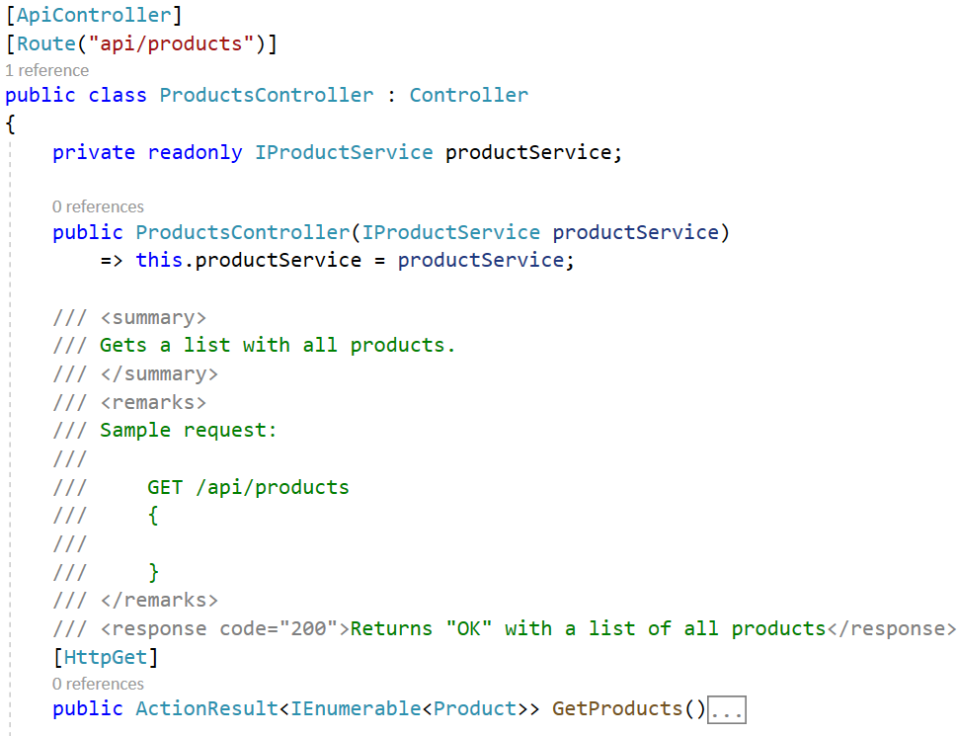

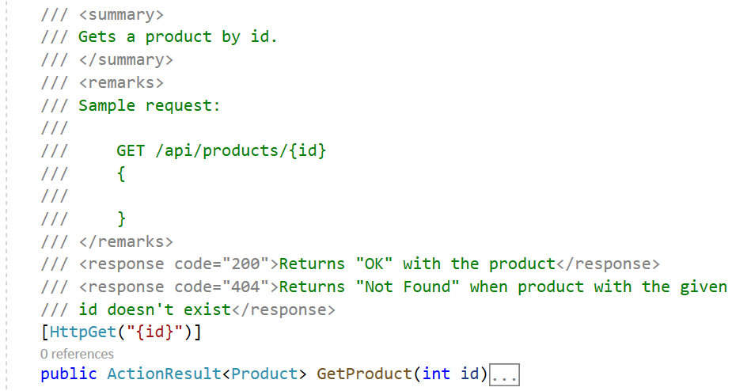

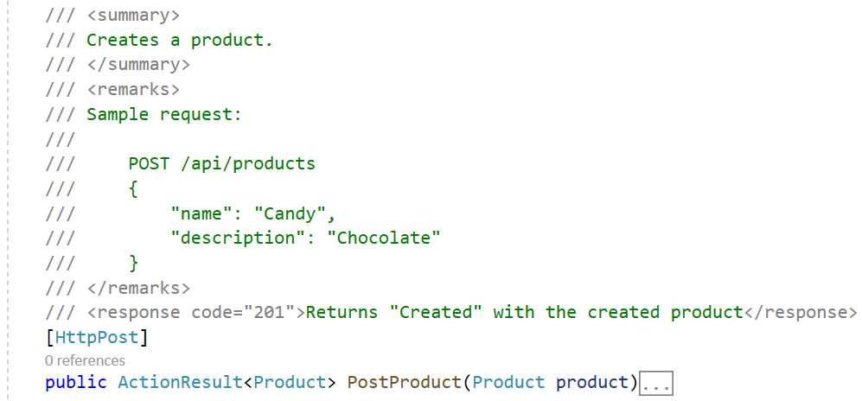

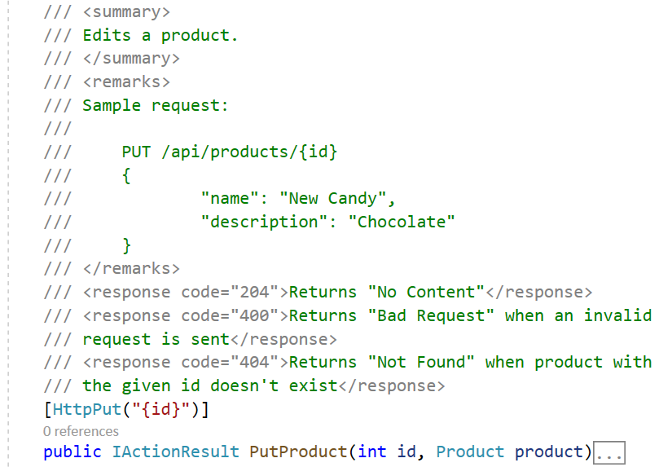



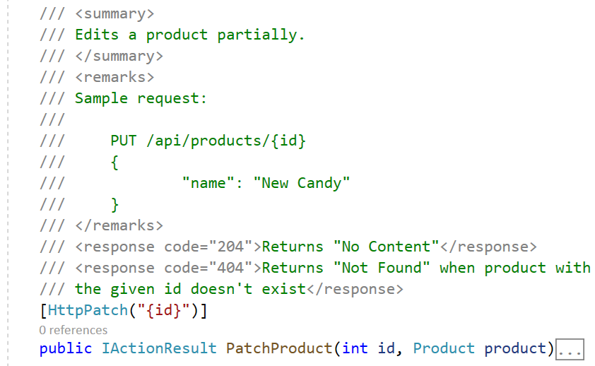

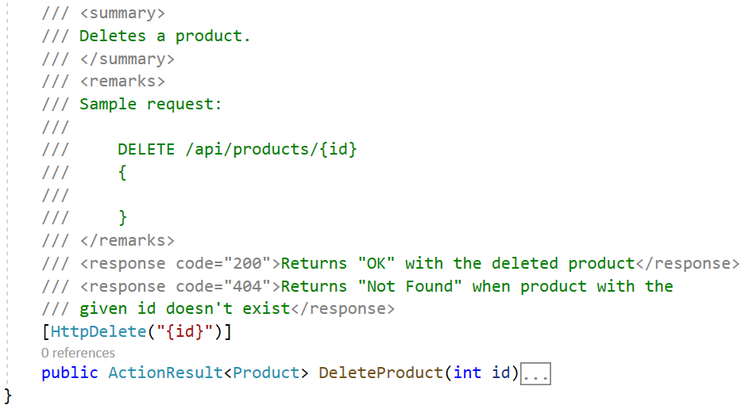

Now **run the app**. Go to your **project's folder** in File Explorer and navigate to "bin" 🡪 "Debug" 🡪 "net5.0" and you should see the **generated XML file** with the **documentation**:

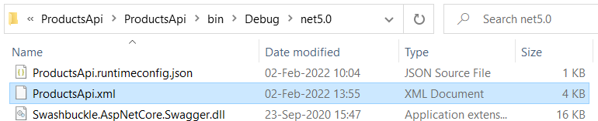 🡪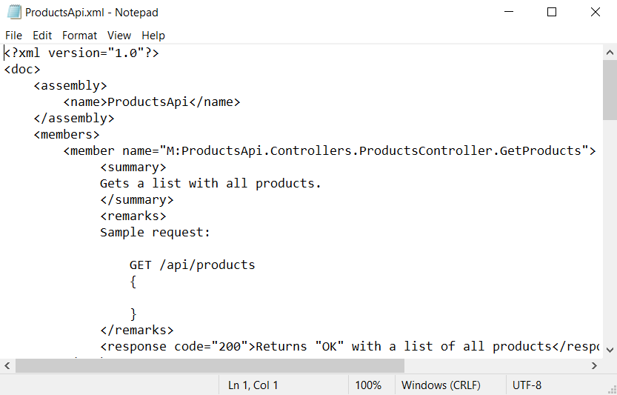

The **app in the browser** should have **these comment on the methods**. For example, this is the "GET" **method** on "/api/products":

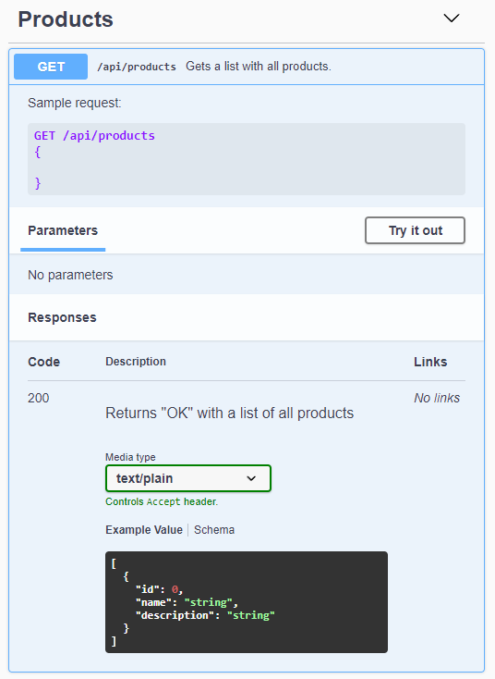

Also, Swagger gives you the opportunity to **try out the methods directly**. To do this, you should **click** on the [Try it out] **button**, add an **URL parameter** or **request body data** if needed, and **click** on the [Execute] **button**. Then, you should see the **response**:

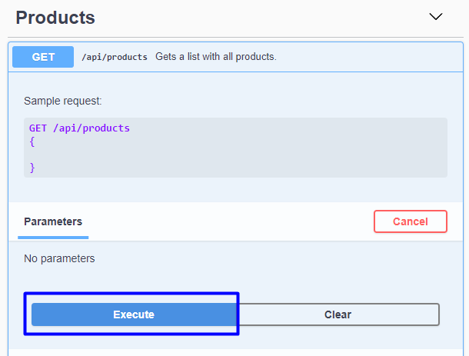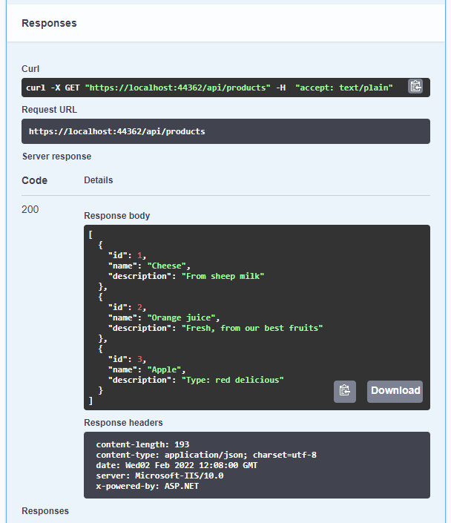

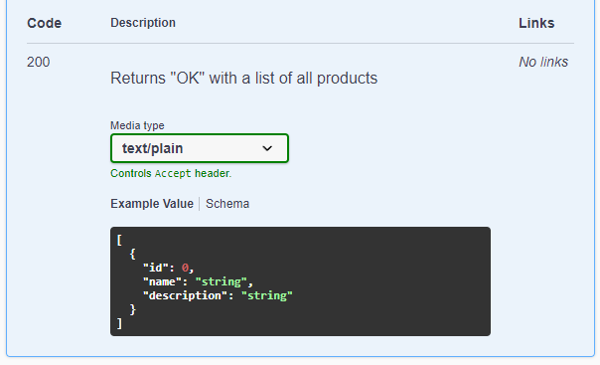

**Try out** the other methods, too. You should be able to **read**, **create**, **edit** and **delete products**.